Article formatting example

Ejemplo del formato de un artículo

Juan David Velásquez-Henao *a* & Mónica del Pilar Rada-Tobón *b*

*a Facultad de Minas, Universidad Nacional de Colombia, Medellín, Colombia. jdvelasq@unal.edu.co*

b Centro Editorial de la Facultad de Minas, Universidad Nacional de Colombia, Medellín, Colombia. mprada@unal.edu.co

Received: September 6th, 2012. Received in revised form: November 1th, 2013. Accepted: November 25th, 2013.

**Abstract**

This is an example of an article formatted for our journal. Note that this text is typed in Times New Roman, size 9, justified, with the word Abstract in bold, Type title and in a separate line. Abstract length does not exceed 150 words. Also, note that keywords are separated by semicolon.

*Keywords*: manuscript formatting; camera-ready manuscript.

**Resumen**

Este es un ejemplo de un artículo formateado para nuestra revista. Note que este texto es digitado en Times New Roman, tamaño 9, justificado, con la palabra Resumen en negrilla, Tipo título y en una línea separada. La longitud del resumen no excede 150 palabras. También, note que las palabras clave están separadas por un punto y coma.

*Palabras clave*: formato del manuscrito; manuscrito listo para impresión.

1 Formating

1.1 Paper size, margins, columns and paragraphs

Manuscript must be prepared in letter size paper with margins of 2.2 cm in the upper and lower sides, of 1.69 cm in inner and outer sides and 0.7 cm Binding. The text is typeset in two columns with 0.40 cm of spacing between columns. All texts in the manuscript are typeset using Time New Roman fonts.

Use Time New Roman font with size of 10 points for normal text paragraphs. The first line of each paragraph is indented 0.5 cm.

1.2 Headings

The maximum allowed deep of headings in the manuscript is three. Headings are numerated using Arabic numbers. Primary headings use bold face, and size 10. Secondary headings use bold face, italics and size 10. Tertiary headings use normal text and size 10, for example:

1.2.1 Example of a tertiary heading

# 2 Tables and Figures

All tables and figures occupy the entire width of the column. Use figures and tables of two columns of width only when absolutely necessary. Tables have the title above and figures have the title below. All tables and figures are numerated consecutively using Arabic numbers. We present an example of correct formatting of tables and figures in the Table 1 and Fig. 1. Locate tables and figures close to the first reference to them, preferably at the beginning or end of each column. No use abbreviations in column headings. For table and figure captions, and the text in tables, use Times New Roman font with size of 8 points. Use only horizontal lines. Avoid text in boldface. Figures with colors are not allowed.

Table 1.

Example of a table.

|  |  |  |
| --- | --- | --- |
| Model | Fitting  MAD (RMSE) | Forecasting  MAD (RMSE) |
| SARIMA | 36.11 (52.30) | 51.88 (60.20) |
| Proposed model | 35.93 (50.89) | 47.68 (60.06) |

Source: Adapted from [2]

# 3 Equations

All equations must be numbered consecutively. Use the built-in equation editor provided by Microsoft Word. Use the standard convention for typesetting mathematics: letters in italics for scalar variables and constants, bold lowercase letters for vectors and bold uppercase letters for matrixes. For example, all variables in eq. (1) are scalars.

|  |  |
| --- | --- |
| $$f\left(x\right)=\frac{1}{σ\sqrt{2π}}\exp\left[-\frac{1}{2}{\left(\frac{x-μ}{σ}\right)}^{2}\right]$$ | (1) |

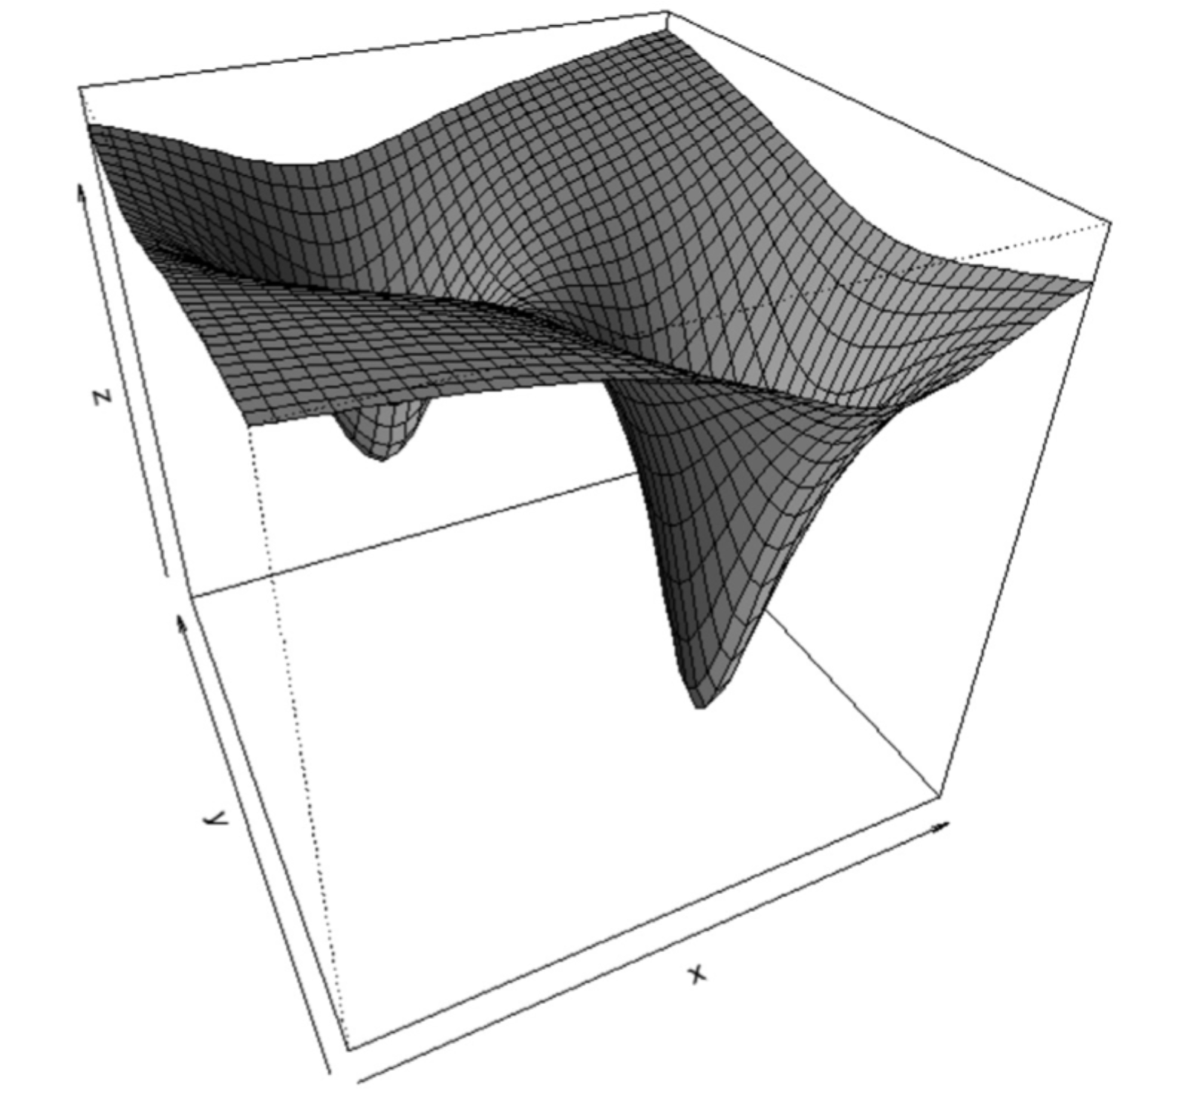

Figure 1. Plot of a nonlinear surface.

Source: [1] or, in case of own source: Source: The authors.

# 4 Referencing bibliography, tables and figures

In text, bibliographical references use [1,2] instead of [1][2]; [1-3] instead of [1][2][3] or [1,2,3] or [1], [2], [3]. For references to figures use Fig. 1 instead of Figure 1; Fig. 1, 2, 5 instead of Figure 1, Figure 2 and Figure 5, or Figures 1, 2 and 5. Use Fig. 1-5 instead of Fig. 1, 2, 3, 4 and 5.

For equations use eq. (1) instead of equation 1; use (eq. 1) instead of (equation 1); use eq. (1)-(5) instead of eq. (1), (2), (3), (4), (5).

5 Citation standard

Use the following citation standard in references.

For books:

1. Masters, T. Neural Network Recipes in C++. New York: Academic Press, 1993.
2. Dvorak, R. and Ferraz-Mello, S., Eds., A Comparison of the dynamical evolution of planetary systems, Austria, Springer, 2004. http://dx.doi.org/10.1007/1-4020-4466-6#sthash.TMeZ8aSQ.dpuf

For Chapter in a printed book:

1. Moyor M.A. Evaluación del lenguaje de ingeniería, en Verdugo – Alonso J. Evaluación curricular: una guía para la intervención del ingeniero, 2a ed., Madrid, Salvat, 1994. pp. 324-344.
2. Hoyles, C. and Noss, R., What can digital technologies take from and bring to research in mathematics education? in Bishop, A.J. et al. Second International Handbook of Mathematics Education, 2nd edition, Dordrecht, Kluwer Academic, 2003, pp. 323-349. <http://dx.doi.org/10.1007/978-94-010-0273-8_11>

For conference articles:

1. [1] Jeng, J.-T., Chuang, C.-C. and Chuang, C.-T., Support vector regression based LTS-CPBUM neural networks, Proceedings of SICE Annual Conference (SICE), 2011. pp. 215-220.
2. Kobus, M., Guerrero, C.D., Labrador, M.A. and Pérez, R.A., CSTEP: Transferring Computer Science Community College Students to Four-year Universities. ASEE Annual Conference and Exposition, (ASEE 2009), Austin, TX., 2009. http://soa.asee.org/paper/conference/paper-view.cfm?id=12459.

For Electronic book:

1. Pumarino A. la propiedad intelectual en ambientes digitales educativos [en línea], Revisión sistemática, Santiago, hile, DoucUC, 2004 [consulta, 1/8 de octubre de 2005]. Available at: <http://www.uca.es/dept/psicologia/bvsss/csalud/memoria/pdf/tecnologia.htlm>

For Chapter in electronic book

1. Anderson S. Multimedia en internet [en línea], California, Agencia de Evaluación de Tecnologías multimedia, 1998  [date of reference May 16 th of 1998], cap. 6, Formación y acreditación de modelos multimedia. Available at: <http://www.usu.edu./sanderso/multinet.pdf>

For Theses and dissertations:

1. Kawasaki, N. Parametric study of thermal and chemical nonequilibrium nozzle flow, MSc. Thesis, Department of Electronic Engineering, Osaka University, Osaka, Japan, 1993.
2. Williams, J. O. Narrow-band analyzer, PhD dissertation, Department of Electrical Engineering, Harvard University, Cambridge, MA, 1993.

For Journals:

1. Ghiassi, M., Saidane, H. and Zimbra, D. K. A dynamic artificial neural network for forecasting time series events. International Journal of Forecasting, 21 (2), pp. 341-362, 2005. <http://dx.doi.org/10.1016/j.ijforecast.2004.10.008>

For Electronic Journal without DOI:

1. Sánchez, A. and Delgado, L., Estado oclusal y rendimiento masticatorio. Acta Odontológica Venezolana [Online]. 44(2), 2006. [date of reference July 25th of 2007]. Available at: <http://www.actaodontologica.com/44_2_2006/estado_oclusal_rendimiento_masticatorio.asp>

For Electronic Journal with DOI:

1. Gonçalves, M., Fox, E., & Watson, L. Towards a digital library theory: a formal digital library ontology, International Journal on Digital Libraries, 8 (2), pp. 91-114, 2008. <http://doi:10.1007/s00799-008-0033-1>

For Report:

1. García–Guadarrama J., Informe de Ingeniería Ambiental, México, División de Estudios de Posgrados de la Facultad de Ingeniería, UNAM, México, 2007, 89 P.

# References

1. Velásquez-Henao, J. D. and Branch-Bedoya, J. W. Examples in the classroom: pattern classification using the R language, DYNA, 79 (173), pp. 81-88, 2012.
2. Velásquez-Henao, J. D., Rueda-Mejía, V. M. and Franco-Cardona, J. D. Electricity demand forecasting using a SARIMA- multiplicative single neuron hybrid model, DYNA, 80 (180), pp. 4-8, 2013.

**J.D. Velásquez-Henao,** received the Bs. Eng in Civil Engineering in 1994, the MS degree in Systems Engineering in 1997, and the PhD degree in Energy Systems in 2009, all of them from the Universidad Nacional de Colombia. Medellin, Colombia. From 1994 to 1999, he worked for electricity utilities and consulting companies within the power sector and since 2000 for the Universidad Nacional de Colombia. Currently, he is a Full Professor in the Computing and Decision Sciences Department, Facultad de Minas, Universidad Nacional de Colombia. His research interests include: simulation, modeling and forecasting in energy markets; nonlinear time-series analysis and forecasting using statistical and computational intelligence techniques; and optimization using metaheuristics.

ORCID: xxx

**M. del P. Rada-Tobón,** received the Bs. Eng in Mining and Metallurgy Engineering in 1996, the Sp degree in Environmental Management in 1998, and MS degree in Environment and Development in 2006, she worked in programs and projects of the mining area, with emphasis on environmental management and since 1998 for the Universidad Nacional de Colombia in the publication of scientific journals. She is currently coordinator of the Editorial Centre, Facultad de Minas, Universidad Nacional de Colombia.

ORCID: xxx